Membership Application
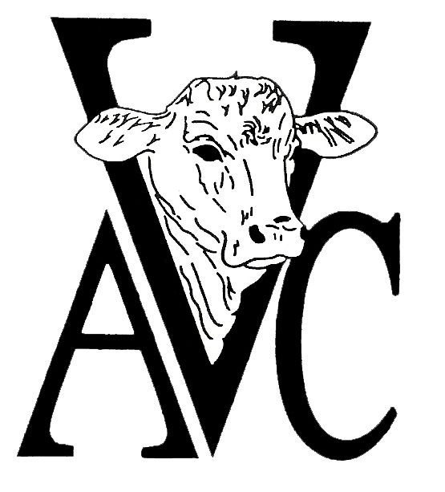
Academy of Veterinary Consultants, Inc
Mail to 305 W Magnolia Street #267, Fort Collins, CO 80521 or email to sobrien@avc-beef.org

Name: __________________________________________________________ Male ___ Female ___ Date: ______________
Clinic/Company:
Mailing Address:
City: _______________________________________________ State: __________ Zip: __________________
Office Phone: ________________________________________ Fax: _________________________________
Mobile: _____________________________________________ Home: _______________________________
E-mail Required: ______________________________________ Signature _________________________________________

University Attended or Currently Attending _____________________________________________ Grad Year: _________
Subscribe to the AVC Listserv: (____Yes ____ No) Applying as a New Member OR renewing a prior membership?
Affiliation (please check one): Consultant / Practitioner _______ Academic / Diagnostic Lab _______
Government _______ Animal Health Industry _______ Veterinary Student _______ (Other) ______________
Primary Practice: Feedlot ______ Stocker ______ Cow/Calf ______ Dairy _____ Mixed ______
Secondary Practice: Feedlot ______ Stocker ______ Cow/Calf ______ Dairy _____ Mixed ______
Are you a member of the: AABP? (____Yes ____ No) NCBA? (____Yes ____ No) AVMA? (____Yes ____ No)
(AVMA membership is encouraged)
References from two AVC Members
Print / Type Name: ___________________________________ Signature: _____________________________
Print / Type Name: ___________________________________ Signature: _____________________________
Application with two AVC members’ signatures and dues must be received at least 14 days prior to a given meeting for AVC Board approval. Membership Dues: $175, Veterinary Student Membership $20/calendar year* If you need assistance in locating members in your area, contact the AVC office. *NOTE TO STUDENTS: Student members shall be students currently attending a college or school of veterinary medicine who have abiding interests in Beef Herd Health Consultation. Student members shall be entitled to all the rights and privileges of active membership except voting and holding office. Upon graduation, student member may be rolled over into active membership with all rights and privileges for the remainder of that calendar year.

Please make your check or money order payable to Academy of Veterinary Consultants or email and remit payment by credit card. Please provide the following information:
Card Type (circle): VISA MC DISC AMEX

Card Number: __________________________________________ Expiration date: __________ Card verification code*:___________
*Visa/MC/Discover: three-digit number on far-right side of signature area/ *AMEX: four-digit number on front of card above card number

Name as appears on card: ____________________________________ Signature: ____________________________________________

Billing address if different from above:

